**TECHNICAL DESIGN DOCUMENT**

**By Heather Peterson – 2018**

**Bellevue University**

**Purpose:**

NodeQuiz is an idealistic approach to allowing company employees to log-in, access, and submit assessment quizzes. The reasoning for online testing is to eliminate the hassle of losing paper documents, allowing employees to quiz at their convenience, and having recorded test scores computed-in to the company system. The user begins by launching the application and entering their employee id to gain access. Once logged in, the user can then select between three presentation slideshows to review quiz material. After reviewing, the user is then given the option to take the one-paged, ten question assessment quiz.

Finally, once the user has completed the question, they can submit their answers and view their test score(s). By using a NoSQL database, the information stored and retrieved will be modeled in such a way that all relations will be recognizable. Angular will be the base platform UI, TypeScript for programming, and JavaScript for output. Through Google’s Material Design, the user will experience a clean, easy-to-navigate experience. This concept can become an extremely reliable tool for storing and obtaining employee information.

**NodeQuiz Terminology**:

Angular – a TypeScript-based open-source front-end web application platform led by the Angular Team at Google and other communities

AngularJS Material – is both a UI component framework and a reference implementation of Google’s Material Design Specification

APIs – (Application Programming Interface) is a set of routines, protocols, and tools for building software applications. Basically, an API specifies how software components should interact. Additionally, APIs are used when programming graphical user interface (GUI) components

Application Server - is a set of routines, protocols, and tools for building software applications. Basically, an API specifies how software components should interact. Additionally, APIs are used when programming graphical user interface (GUI) components

Express – or simply Express, is a web application framework for Node.js, released as free and open-source software under the MIT License. It is designed for building web applications and APIs

Heroku - used for deployment; a platform as a service (PaaS) that enables developers to build, run, and operated applications entirely in the cloud

Log Files - a history of actions executed by a database management system and recorded to avoid losses in crashes or hardware failures; also known as a *transaction log*

MongoDB - is a free and open-source cross-platform document-oriented database program. Classified as a NoSQL database program, MongoDB uses JSON-like documents

mLab - Database-as-a-Service for MongoDB. mLab is a fully managed cloud database service featuring automated provisioning and scaling of MongoDB databases, backup and recovery, 24/7 monitoring and alerting, web-based management tools, and expert support. mLab runs on cloud providers Amazon, Google, and Microsoft Azure, and has partnered with platform-as-a-service providers

Node – (1) an individual computing device in a network; (2) a connection point in a data structure such as a linked list or tree

Node.js - is a JavaScript runtime built on Chrome's V8 JavaScript engine. Node.js uses an event-driven, non-blocking I/O model; npm

NoSQL– “non-relational” database that provides a mechanism for storing and retrieving data that is modeled in means other than the tabular relations used in relational databases

Relational Database – a database that consists of tables made up of rows and columns that are used to define relation between the contained data

TypeScript – is an open-source programming language designed for development of large applications and is a subset of JavaScript

URI – (Uniform Resource Identifier)

URL – (Uniform Resource Locator)



User Stories

**THE User (employee) -**

* As a user, I need to be able to access NodeQuiz using my employee ID number, so that I can test and record my overall scores.
* As a user, I need material to cover navigation and quizzes, so that I have thorough understanding of what types of questions will be presented.
* As a user, I need to be able to read through the *review presentations* at my leisure, so that I have time to study when it’s convenient for myself.
* As a user, I need to be able to read through and *submit the quiz* at my leisure, so that I have time to complete the quiz when it’s convenient for myself.
* As a user, I need to be able to access my test results and overall test scores, so that I can see what areas I succeeded in and what may need improvement(s).

**THE UI/UX Developer/Designer -**

* As a developer/designer, I need to create an employee_ID field that accepts numeric values in relation to the user database.
* As a developer/designer, I need to develop a slide-show presentation, so that the user has material to review prior to the quiz assessments.
* As a developer/designer, I need to create a one-page quiz template that accepts radio and submit button input, so that the user can complete and submit their quizzes.
* As a developer/designer, I need to create a functionality that is able to calculate the amount correct/incorrect selections and output an overall score, so that the user can see what the results of their quizzes are.
* As a developer/designer, I need to add three separate quiz selections that are easy to locate and navigate through, so that the user understands how to access and use each section to its entirety.

**THE Company/Site Owner -**

* As the company/site owner, I need to review and discuss all portions of the quizzes being presented, so that the employees are aware of the new application software.
* As the company/site owner, I need to verify that each employee_ID is unique to that of the employee, so that there is accurate output information connected to the user.
* As the company/site owner, I need to be aware of the presentations being presented, so that I can address any questions or concerns the employees may have.
* As the company/site owner, I need to have an understanding of how the NodeQuiz application works, so that I can not only navigate others but also access quiz scores.
* As the company/site owner, I need to make sure all the application functions are working properly and that all quiz answers are matching with the user’s selection, so that there is an assurance that all I/O information is valid.

Time Estimations

|  |  |  |
| --- | --- | --- |
| ***As a UI web developer, I need to create a NodeQuiz*** | ***Work*** | ***Points*** |
| ***application so employees can access and take quiz assessments*** | ***Hours*** |  |
|  |  |  |
| 1. Add functioning employee_ID field to access application | 3 | 4 |
| 2. Create three separate active quiz sessions for user to select. | 6 | 8 |
| 3. Implement submit buttons for employee_ID and quiz submissions. | 5 | 6 |
| 4. Add active “Previous/Next” buttons for users to view all presentation slides. | 2 | 4 |
| 5. Develop overall grading functionality that calculates and outputs test scores. | 6 | 9 |
| TOTAL HOURS: | 22 | 31 |
|  |  |  |
| ***As a UI web designer, I need to incorporate easy navigation*** | ***Work*** | ***Points*** |
| ***so that owners/employees can easily use the NodeQuiz application*** | ***Hours*** |  |
|  |  |  |
| 1. Display a simplified “Enter Here” field and submit button for users to access. | 1 | 2 |
| 2. Once accessed, display three selectable options with visible quiz name titles. | 3 | 5 |
| 3. When user selects a quiz, begin the presentation slide and scroll buttons | 3 | 5 |
| 4. At the end of the presentation slide, apply a “Take Quiz” button. | 1 | 2 |
| 5. Display a one-paged, 10-question quiz complete with radio button selectors. | 3 | 8 |
| TOTAL HOURS: | 11 | 22 |
|  |  |  |
|  |  |  |

Prototypes

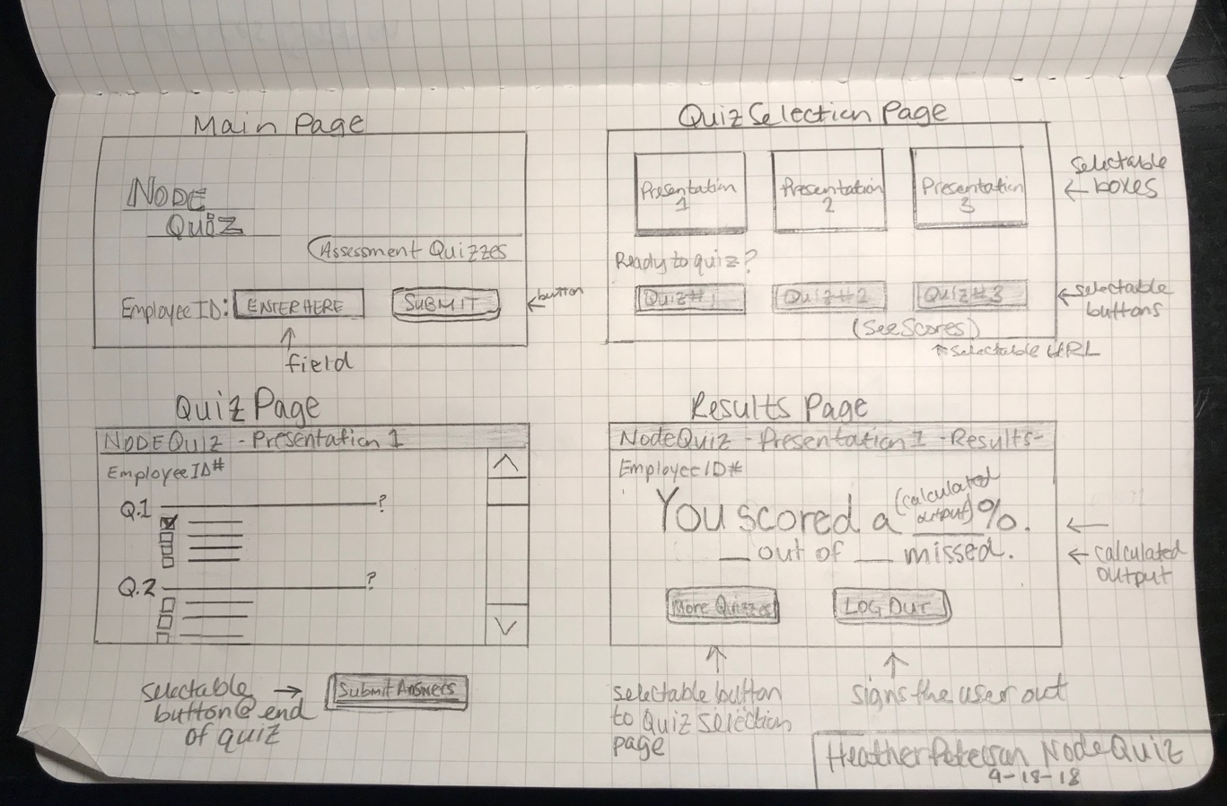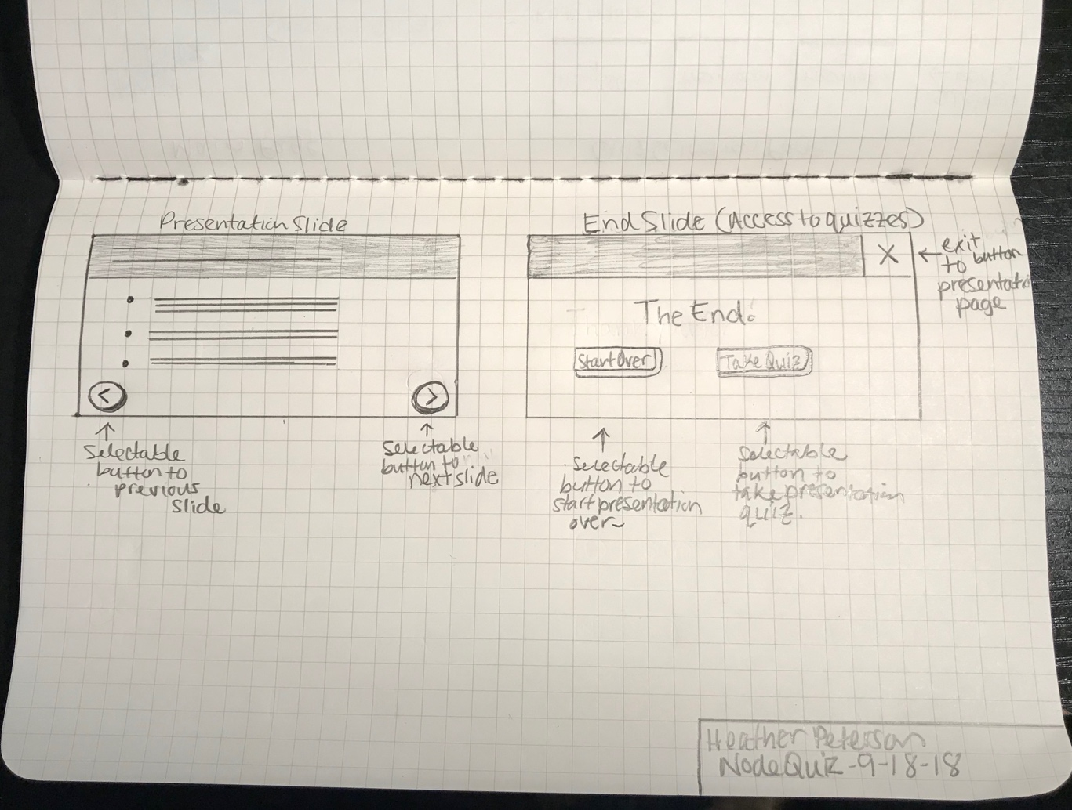

**Predefined employee_ID’s (MongoDB collection)**

{

employee_ID: 81710,

employeeName: “Jane “ + “Smith”,

}

*(have at least one, no more than 5.)*

**MongoDB database design -**

*Business Rules*

A user can log-in to access one or many quizzes.

Many quizzes can be accessed by one or many users.

A user can access their stored results,

Stored results can be accessed by the user.

A user can take one or many quizzes.

One or many quizzes can be taken by one or many users.

A quiz can have many questions.

Many questions can be on one or many quizzes.

A question can have one or many answers.

Many answers can be on one or many quizzes.

**ORD**

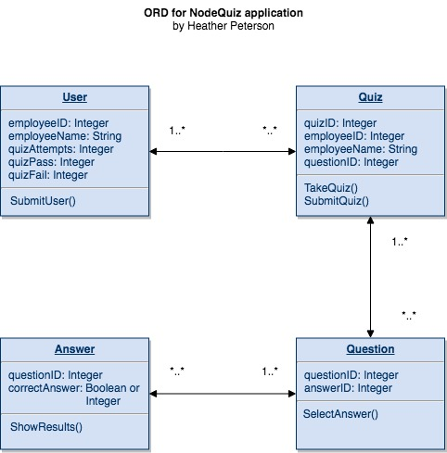

**NoSQL Document Diagram (added Results collection)**

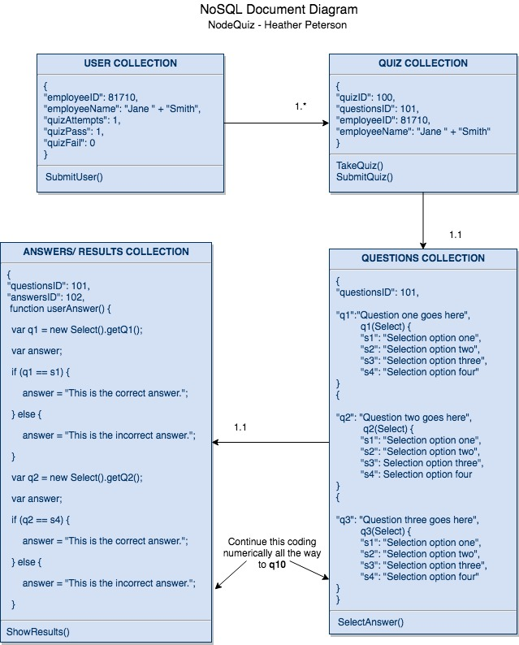

**NoSQL Data Structure**

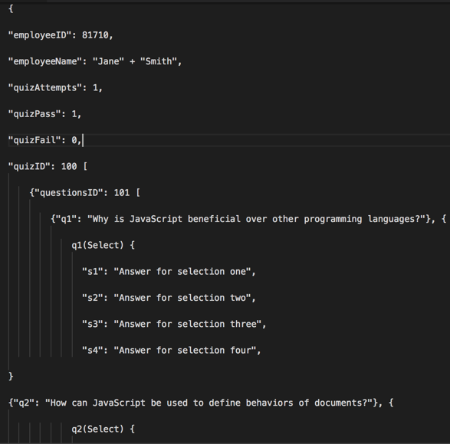

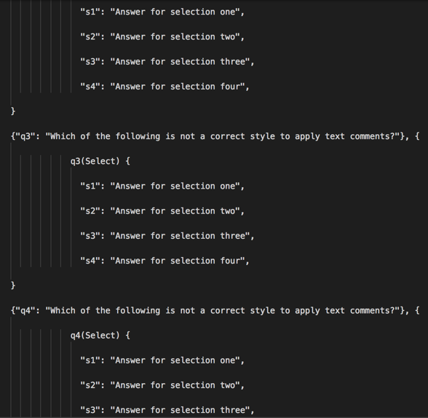

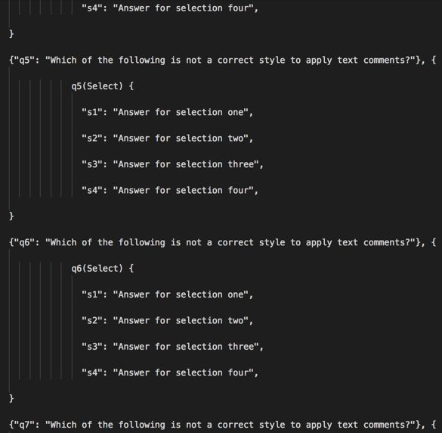

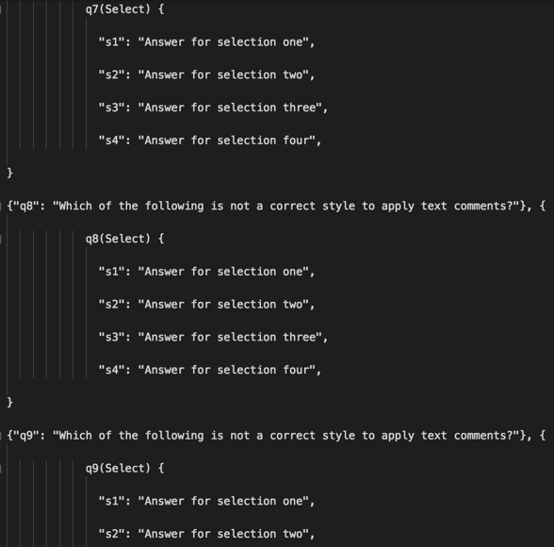

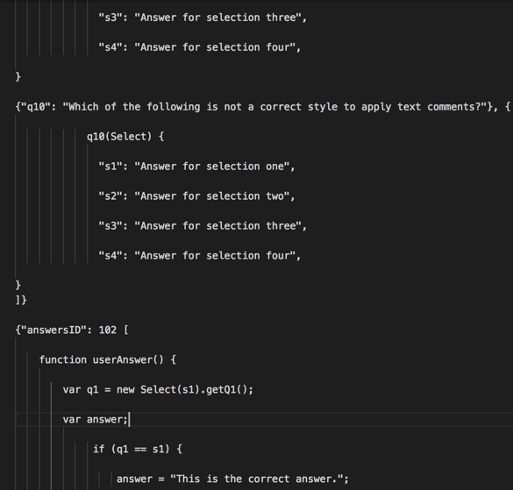

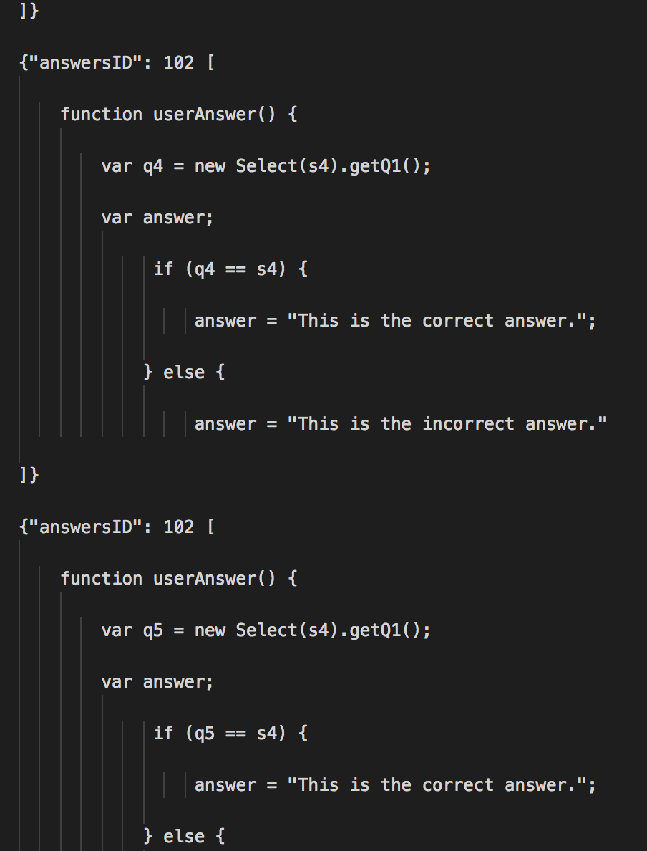

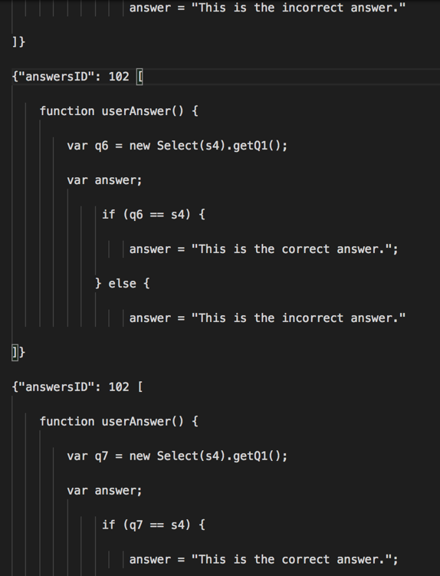

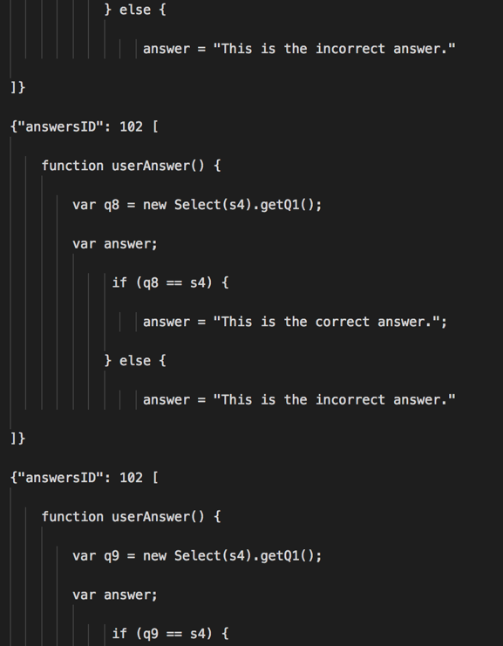

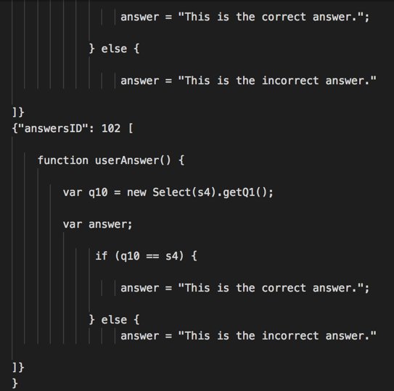

**Running Login Page (working Employee ID entry and “Welcome!” greeting)**

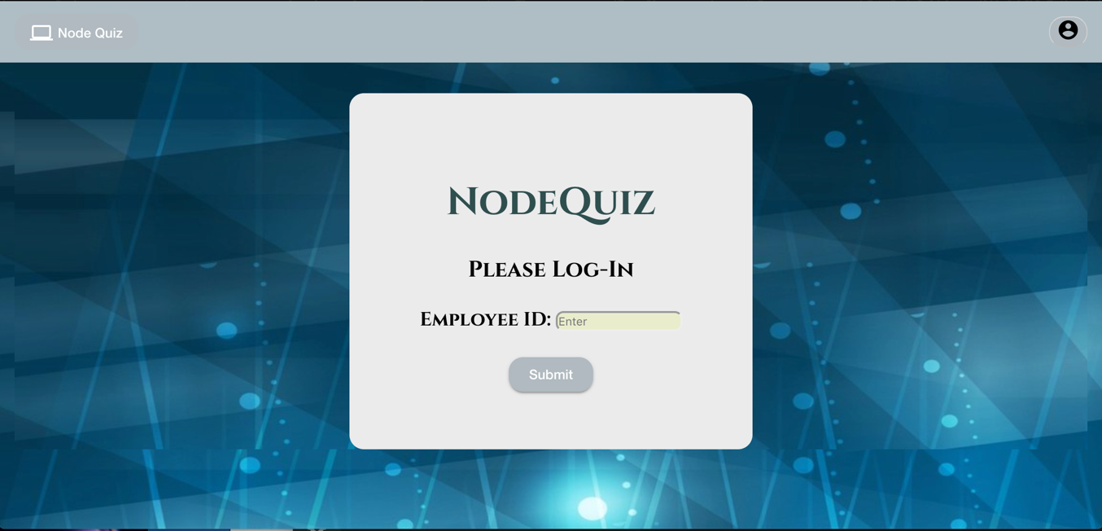

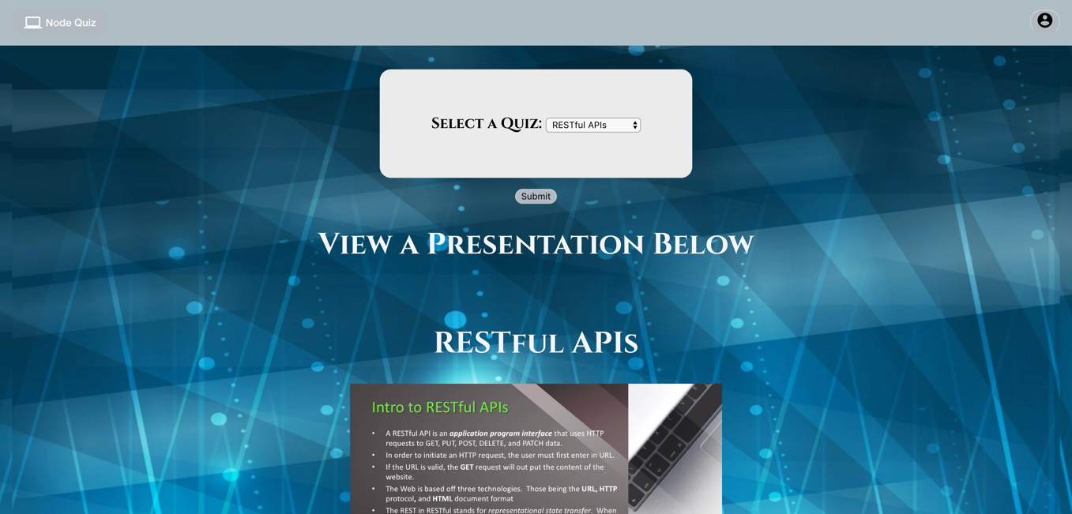

Presentations View

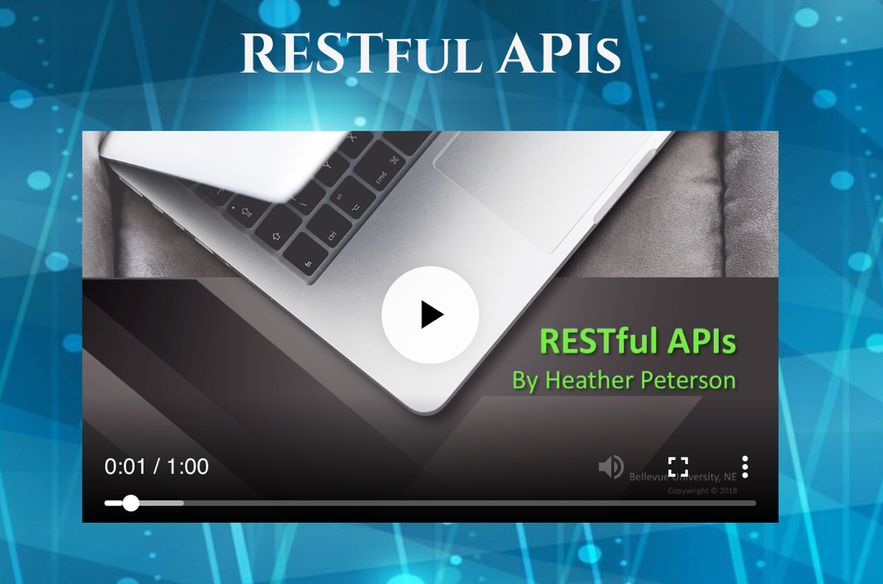

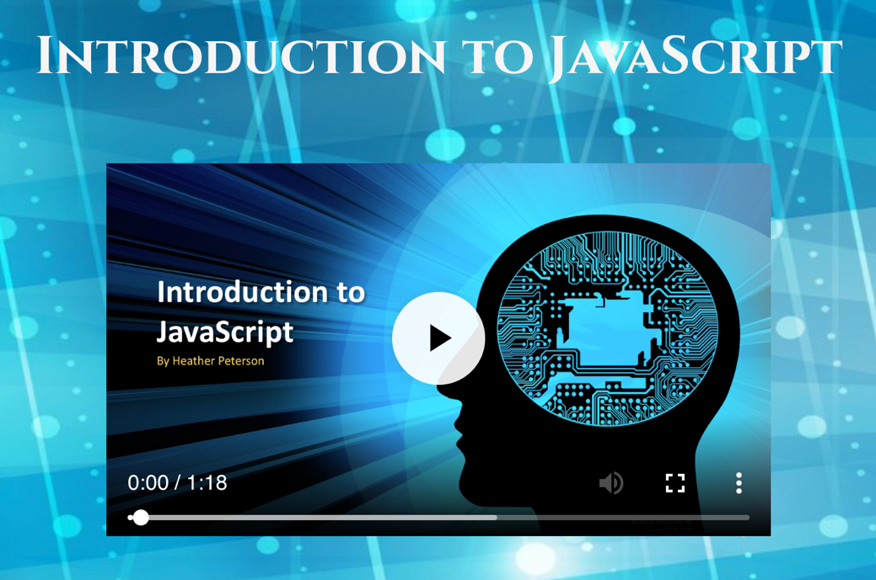

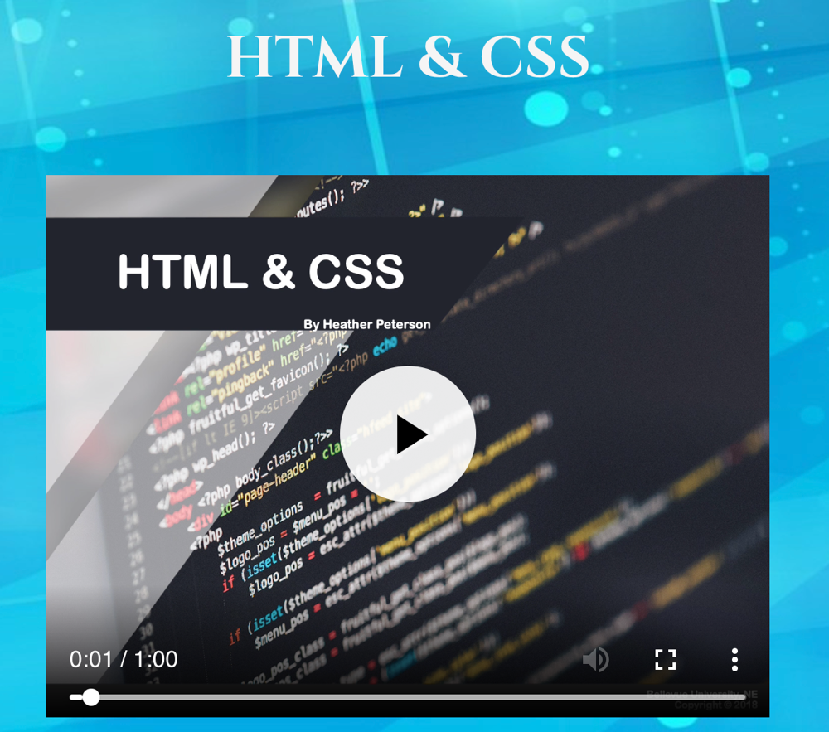

Quiz Question Form Demo

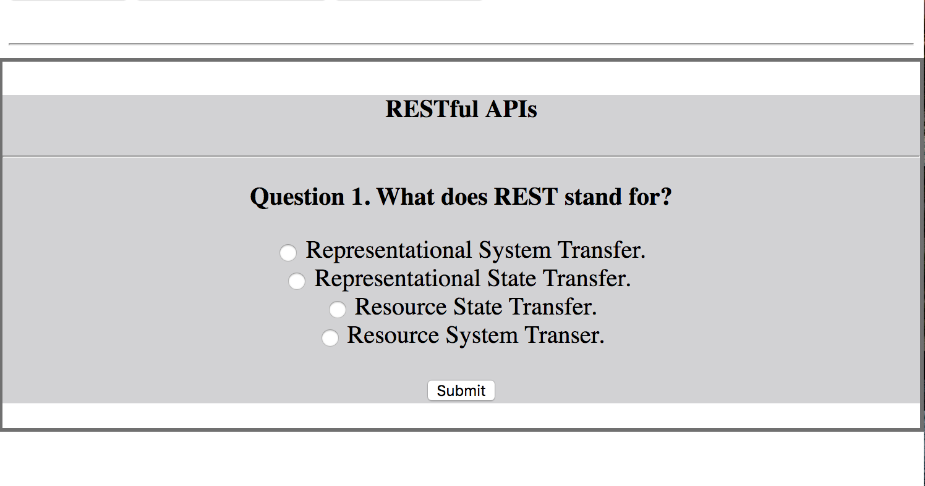

EACH QUIZ’S QUESTIONS AND ANSWERS

RESTful APIs Questions and Answers

1. ***What does REST stand for? A. Representational State Transfer.***
2. ***REST relies on a statelessness, client-server protocol, which is almost always ______? A. HTTP.***
3. ***What does API stand for? A. Application program interface.***
4. ***The Web is based off what three technologies? A. URL, HTTP, HTML.***
5. ***The goal of ________ is to improve server scalability by eliminating any need for the server to maintain an awareness of the client state beyond the current request. A. Statelessness.***
6. ***Which HTTP verb (command) updates a specified resource? A. PUT.***
7. ***Which of the following are considered an advantage of RESTful APIs? A. All of the above. ( Flexibility. Statelessness. High-performance. )***
8. ***Which of the following are considered a disadvantage of RESTful APIs? A. All of the above. ( Challenges with passing test runs. Costly programming procedures. Complex functionality structures. )***
9. ***Every URI is a URL? A. False.***
10. ***If the URL is valid, the ____ request will output the content of the website. A. GET.***

JavaScript Questions and Answers

***1. Why use the JavaScript language? A. It is a widely-used programming language of the Web and is used to specify the behavior of a page.***

***2. Client-side JavaScript programmers like to use client-side libraries such as _________ to simplify their work tasks. A. jQuery.***

***3. Which style is not a correct way to apply text comments to JavaScript code? A. */***

***4. Functions are considered which type of JavaScript object? A. Native object.***

***5. How does JavaScript enhance user experience in Web browsers? A. By creating animations and other visual effects through sorting, hiding, and revealing details as user interacts with page content.***

***6. What element tags are used to input JavaScript into an HTML file? A. <script> and </script>.***

***7. What is the proper JavaScript function syntax? A. function helloWorld() {}.***

***8. What is the for loop syntax? A.* for(var x = 0; x < a.length; x++)**

***9. The ______ means that* every time the loop has run the statements in the {}, one is added to the x (counter)*? A.* x++**

***10. What is the combination of scriptable content, presentation, and behavior called? A. Dynamic HTML or DHTML.***

HTML & CSS

1. ***What is the combination of scriptable content, presentation, and behavior called? A. Dynamic HTML or DHTML.***
2. ***What are some elements that make up the HTML5 layout? A. Nav, section, article, aside.***
3. ***HTML links are created using the _______ element. A. <a>***
4. ***Which HTML element exists within another list element? A. The list element. <li>***
5. ***Where can you place images in your HTML code? A. All of the above. (Before a paragraph, Inside the start of a paragraph, In the middle of a paragraph).***
6. ***What does CSS stand for and what is it used for? Cascading Style Sheets; Specifying the presentation of a page.***
7. ***What are three ways to specify color in CSS? A. RGB, Hex, and color name.***
8. ***What properties can be used to specify background values? A. All of the above. (background-color, background-image, background-position)***
9. ***Why are tables important? A. Tables represent information in a grid format, such as, financial reports, TV schedules, and sports results.***
10. ***Every box has three available properties. In order from outermost to inner, what is the order of appearance? A. Margin, border, padding.***

RESTful API Quiz in HTML (This is where errors began, as I was later aware they needed to be in the MongoDB, not stored in an HTML format so this coding is still valid and runs.)

<!DOCTYPE html>

<html>

<head>

<meta charset="utf-8">

<meta http-equiv="X-UA-Compatible" content="IE=edge,chrome=1">

</head>

<body>

<style>

#frame1 {

position: fixed;

border: 3px solid black;

top: 0;

left: 0;

right: 0;

z-index: 2;

color:rgb(190, 191, 192);

}

#center1 {

text-align: center;

color: black;

}

</style>

<div id = "frame1">

<div id = "center1">

<h4>RESTful APIs</h4>

<hr />

<p id= "messages1"></p>

<p id= "options1"></p>

<p id= "click1"></p>

<p id= "comment1"></p>

</div>

</div>

<script>

var question1 = ["<b>Question 1. What does REST stand for? </b>"];

var choices1 = ["<input onclick=incorrect1() name =button1 type=radio /> Representational System Transfer.<br /><input onclick=correct1() name=button1 type=radio /> Representational State Transfer. <br /><input onclick=incorrect1() name=button1 type=radio /> Resource State Transfer.<br /><input onclick=incorrect1() name=button1 type=radio /> Resource System Transer. "]

var question2 = ["<b>Question 2. REST relies on a statelessness, client-server protocol, which is almost always ______? </b>"];

var choices2 = ["<input onclick=incorrect2() name =button2 type=radio /> JSON <br /><input onclick=incorrect2() name=button2 type=radio /> XML <br /><input onclick=incorrect2() name=button2 type=radio /> SOAP <br /><input onclick=correct2() name=button2 type=radio /> HTTP "]

var question3 = ["<b>Question 3.  What does API stand for? </b>"];

var choices3 = ["<input onclick=correct1() name =button3 type=radio /> Application Program Interface. <br /><input onclick=incorrect1() name=button3 type=radio /> Application Program Identifier.<br /><input onclick=incorrect1() name=button3 type=radio /> Application Protocol Indexing. <br /><input onclick=incorrect1() name=button3 type=radio /> Analaysis Program Interface. "]

var question4 = ["<b>Question 4.  The Web is based off what three technologies? </b>"];

var choices4 = ["<input onclick=incorrect1() name =button4 type=radio /> HTML, CSS, HTTP <br /><input onclick=correct1() name=button4 type=radio /> URL, HTTP, HTML <br /><input onclick=incorrect1() name=button4 type=radio /> GET, POST, PUT <br /><input onclick=incorrect1() name=button4 type=radio /> URI, URL, CSS "]

var question5 = ["<b>Question 5. The goal of ________ is to improve server scalability by eliminating any need for the server to maintain an awareness of the client state beyond the current request. </b>"];

var choices5 = ["<input onclick=correct1() name =button5 type=radio /> Statelessness <br /><input onclick=incorrect1() name=button5 type=radio /> a state transition <br /><input onclick=incorrect1() name=button5 type=radio /> transclusion <br /><input onclick=incorrect1() name=button5 type=radio /> table scanning "]

var question6 = ["<b>Question 6.  Which HTTP verb (command) updates a specified resource ?</b>"];

var choices6 = ["<input onclick=incorrect1() name =button6 type=radio /> HEAD <br /><input onclick=incorrect1() name=button6 type=radio /> GET <br /><input onclick=correct1() name=button6 type=radio /> PUT <br /><input onclick=incorrect1() name=button6 type=radio /> POST "]

var question7 = ["<b>Question 7.  Which of the following are considered an <i>advantage</i> of RESTful APIs? </b>"];

var choices7 = ["<input onclick=incorrect1() name =button7 type=radio /> Flexibility. <br /><input onclick=incorrect1() name=button7 type=radio /> Statelessness. <br /><input onclick=incorrect1() name=button7 type=radio /> High-performance. <br /><input onclick=correct1() name=button7 type=radio /> All of the above. "]

var question8 = ["<b>Question 8.  Which of the following are considered a <i>disadvantage</i> of RESTful APIs? </b>"];

var choices8 = ["<input onclick=incorrect1() name =button8 type=radio /> Challenges with passing test runs. <br /><input onclick=incorrect1() name=button8 type=radio /> Costly programming procedures. <br /><input onclick=incorrect1() name=button8 type=radio /> Complex functionality structures. <br /><input onclick=correct1() name=button8 type=radio /> All of the above. "]

var question9 = ["<b>Question 9.  Every URI is a URL? </b>"];

var choices9 = ["<input onclick=incorrect1() name =button9 type=radio /> True <br /><input onclick=correct1() name=button9 type=radio /> False <br />"]

var question10 = ["<b>Question 10.  If the URL is valid, the ____ request will output the content of the website. </b>"];

var choices10 = ["<input onclick=correct1() name =button10 type=radio /> GET <br /><input onclick=incorrect1() name=button10 type=radio /> POST <br /><input onclick=incorrect1() name=button10 type=radio /> PUT <br /><input onclick=incorrect1() name=button10 type=radio /> HEAD"]

var a;

var b;

var c;

var d;

var e;

var f;

var g;

var h;

var i;

var j;

window.onload = function () {

messages1.innerHTML = question1;

options1.innerHTML = choices1;

click1.innerHTML = "<button onclick=set2()>Submit</button>";

}

function correct1() {

a = 1;

}

function incorrect1() {

a = 0;

}

function set2() {

messages1.innerHTML = question2;

options1.innerHTML = choices2;

click1.innerHTML = "<button onclick=set3()>Submit</button>";

}

function correct1() {

b = 1;

}

function incorrect1() {

b = 0;

}

function set3() {

messages1.innerHTML = question3;

options1.innerHTML = choices3;

click1.innerHTML = "<button onclick=set4()>Submit</button>";

}

function correct1() {

c = 1;

}

function incorrect1() {

c = 0;

}

function set4() {

messages1.innerHTML = question4;

options1.innerHTML = choices4;

click1.innerHTML = "<button onclick=set5()>Submit</button>";

}

function correct1() {

d = 1;

}

function incorrect1() {

d = 0;

}

function set5() {

messages1.innerHTML = question5;

options1.innerHTML = choices5;

click1.innerHTML = "<button onclick=set6()>Submit</button>";

}

function correct1() {

e = 1;

}

function incorrect1() {

e = 0;

}

function set6() {

messages1.innerHTML = question6;

options1.innerHTML = choices6;

click1.innerHTML = "<button onclick=set7()>Submit</button>";

}

function correct1() {

f = 1;

}

function incorrect1() {

f = 0;

}

function set7() {

messages1.innerHTML = question7;

options1.innerHTML = choices7;

click1.innerHTML = "<button onclick=set8()>Submit</button>";

}

function correct1() {

g = 1;

}

function incorrect1() {

g = 0;

}

function set8() {

messages1.innerHTML = question8;

options1.innerHTML = choices8;

click1.innerHTML = "<button onclick=set9()>Submit</button>";

}

function correct1() {

h = 1;

}

function incorrect1() {

h = 0;

}

function set9() {

messages1.innerHTML = question9;

options1.innerHTML = choices9;

click1.innerHTML = "<button onclick=set10()>Submit</button>";

}

function correct1() {

i = 1;

}

function incorrect1() {

i = 0;

}

function set10() {

messages1.innerHTML = question10;

options1.innerHTML = choices10;

click1.innerHTML = "<button onclick=results1()>Submit</button>";

}

function correct1() {

j = 1;

}

function incorrect1() {

j = 0;

}

</script>

</body>

</html>

Introduction to JavaScript Quiz in HTML

<!DOCTYPE html>

<html>

<head>

<meta charset="utf-8">

<meta http-equiv="X-UA-Compatible" content="IE=edge,chrome=1">

</head>

<body>

<style>

#frame1 {

position: fixed;

border: 3px solid black;

top: 0;

left: 0;

right: 0;

z-index: 2;

color:rgb(190, 191, 192);

}

#center1 {

text-align: center;

color: black;

}

</style>

<div id = "frame1">

<div id = "center1">

<h4>Introduction to JavaScript Assessment Quiz</h4>

<hr />

<p id= "messages1"></p>

<p id= "options1"></p>

<p id= "click1"></p>

<p id= "comment1"></p>

</div>

</div>

<script>

var question1 = ["<b>Question 1. Why use the JavaScript language? </b>"];

var choices1 = ["<input onclick=correct1() name =button1 type=radio /> It is a widely-used programming language of the Web and is used to specify the behavior of a page. <br /><input onclick=incorrect1() name=button1 type=radio /> It is the easiest of all the programming languages to use. <br /><input onclick=incorrect1() name=button1 type=radio /> It is the only programming language used to specify page behavior. <br /><input onclick=incorrect1() name=button1 type=radio /> It isn't a commonly used language but is effective."]

var question2 = ["<b>Question 2. Client-side JavaScript programmers like to use client-side libraries such as _________ to simplify their work tasks.</b>"];

var choices2 = ["<input onclick=incorrect2() name =button2 type=radio /> JavaScript. <br /><input onclick=correct2() name=button2 type=radio /> jQuery. <br /><input onclick=incorrect2() name=button2 type=radio /> Angular. <br /><input onclick=incorrect2() name=button2 type=radio /> React."]

var question3 = ["<b>Question 3. Which style is <u>not</u> a correct way to apply text comments to JavaScript code? </b>"];

var choices3 = ["<input onclick=correct1() name =button3 type=radio /> */ <br /><input onclick=incorrect1() name=button3 type=radio /> /* <br /><input onclick=incorrect1() name=button3 type=radio /> // <br /><input onclick=incorrect1() name=button3 type=radio /> All of the above."]

var question4 = ["<b>Question 4. Functions are considered which type of JavaScript object? </b>"];

var choices4 = ["<input onclick=incorrect1() name =button4 type=radio /> Root object. <br /><input onclick=incorrect1() name=button4 type=radio /> Complex object. <br /><input onclick=correct1() name=button4 type=radio /> Native object. <br /><input onclick=incorrect1() name=button4 type=radio /> Singular object. "]

var question5 = ["<b>Question 5. How does JavaScript enhance user experience in Web browsers? </b>"];

var choices5 = ["<input onclick=incorrect1() name =button5 type=radio /> By specifiying the page content. <br /><input onclick=incorrect1() name=button5 type=radio /> By specifying the presentation of a page. <br /><input onclick=correct1() name=button5 type=radio /> By creating animations and other visual effects through sorting, hiding, and revealing details as user interacts with page content. <br /><input onclick=incorrect1() name=button5 type=radio /> None of the above."]

var question6 = ["<b>Question 6. What element tags are used to input JavaScript into an HTML file? </b>"];

var choices6 = ["<input onclick=incorrect1() name =button6 type=radio /> &lt; style &gt;and&lt; /style &gt; <br /><input onclick=incorrect1() name=button6 type=radio /> &lt; body &gt;and&lt; /body &gt;<br /><input onclick=incorrect1() name=button6 type=radio /> &lt; a &gt;and&lt; /a &gt;<br /><input onclick=correct1() name=button6 type=radio /> &lt; script &gt;and&lt; /script &gt;"]

var question7 = ["<b>Question 7. What is the proper JavaScript function syntax? </b>"];

var choices7 = ["<input onclick=incorrect1() name =button7 type=radio />A. <br /><input onclick=incorrect1() name=button7 type=radio />B. Choice Two<br /><input onclick=incorrect1() name=button7 type=radio />C. Choice Three<br /><input onclick=correct1() name=button7 type=radio /> function helloWorld() {}."]

var question8 = ["<b>Question 8. What is the for loop syntax? </b>"];

var choices8 = ["<input onclick=correct1() name =button8 type=radio /> for(var x = 0; x < a.length; x++) <br /><input onclick=incorrect1() name=button8 type=radio />B. Choice Two<br /><input onclick=incorrect1() name=button8 type=radio />C. Choice Three<br /><input onclick=incorrect1() name=button8 type=radio />D. Choice Four"]

var question9 = ["<b>Question 9. The ______ means that every time the loop has run the statements in the {}, one is added to the x (counter)? </b>"];

var choices9 = ["<input onclick=incorrect1() name =button9 type=radio />A. <br /><input onclick=incorrect1() name=button9 type=radio />B. Choice Two<br /><input onclick=correct1() name=button9 type=radio /> x++ <br /><input onclick=incorrect1() name=button9 type=radio />D. Choice Four"]

var question10 = ["<b>Question 10. What is the combination of scriptable content, presentation, and behavior called? </b>"];

var choices10 = ["<input onclick=correct1() name =button10 type=radio /> Dynamic HTML or DHTML. <br /><input onclick=incorrect1() name=button10 type=radio />B. Choice Two<br /><input onclick=incorrect1() name=button10 type=radio />C. Choice Three<br /><input onclick=incorrect1() name=button10 type=radio />D. Choice Four"]

var a;

var b;

var c;

var d;

var e;

var f;

var g;

var h;

var i;

var j;

window.onload = function () {

messages1.innerHTML = question1;

options1.innerHTML = choices1;

click1.innerHTML = "<button onclick=set2()>Submit</button>";

}

function correct1() {

a = 1;

}

function incorrect1() {

a = 0;

}

function set2() {

messages1.innerHTML = question2;

options1.innerHTML = choices2;

click1.innerHTML = "<button onclick=set3()>Submit</button>";

}

function correct1() {

b = 1;

}

function incorrect1() {

b = 0;

}

function set3() {

messages1.innerHTML = question3;

options1.innerHTML = choices3;

click1.innerHTML = "<button onclick=set4()>Submit</button>";

}

function correct1() {

c = 1;

}

function incorrect1() {

c = 0;

}

function set4() {

messages1.innerHTML = question4;

options1.innerHTML = choices4;

click1.innerHTML = "<button onclick=set5()>Submit</button>";

}

function correct1() {

d = 1;

}

function incorrect1() {

d = 0;

}

function set5() {

messages1.innerHTML = question5;

options1.innerHTML = choices5;

click1.innerHTML = "<button onclick=set6()>Submit</button>";

}

function correct1() {

e = 1;

}

function incorrect1() {

e = 0;

}

function set6() {

messages1.innerHTML = question6;

options1.innerHTML = choices6;

click1.innerHTML = "<button onclick=set7()>Submit</button>";

}

function correct1() {

f = 1;

}

function incorrect1() {

f = 0;

}

function set7() {

messages1.innerHTML = question7;

options1.innerHTML = choices7;

click1.innerHTML = "<button onclick=set8()>Submit</button>";

}

function correct1() {

g = 1;

}

function incorrect1() {

g = 0;

}

function set8() {

messages1.innerHTML = question8;

options1.innerHTML = choices8;

click1.innerHTML = "<button onclick=set9()>Submit</button>";

}

function correct1() {

h = 1;

}

function incorrect1() {

h = 0;

}

function set9() {

messages1.innerHTML = question9;

options1.innerHTML = choices9;

click1.innerHTML = "<button onclick=set10()>Submit</button>";

}

function correct1() {

i = 1;

}

function incorrect1() {

i = 0;

}

function set10() {

messages1.innerHTML = question10;

options1.innerHTML = choices10;

click1.innerHTML = "<button onclick=results1()>Submit</button>";

}

function correct1() {

j = 1;

}

function incorrect1() {

j = 0;

}

</script>

</body>

</html>

HTML & CSS Quiz in HTML

<!DOCTYPE html>

<html>

<head>

<meta charset="utf-8">

<meta http-equiv="X-UA-Compatible" content="IE=edge,chrome=1">

</head>

<body>

<style>

#frame1 {

position: fixed;

border: 3px solid black;

top: 0;

left: 0;

right: 0;

z-index: 2;

color:rgb(190, 191, 192);

}

#center1 {

text-align: center;

color: black;

}

</style>

<div id = "frame1">

<div id = "center1">

<h4>HTML & CSS</h4>

<hr />

<p id= "messages1"></p>

<p id= "options1"></p>

<p id= "click1"></p>

<p id= "comment1"></p>

</div>

</div>

<script>

var question1 = ["<b>Question 1. What is the combination of scriptable content, presentation, and behavior called? </b>"];

var choices1 = ["<input onclick=correct1() name =button1 type=radio /> Dynamic HTML or DHTML <br /><input onclick=incorrect1() name=button1 type=radio /> JavScript <br /><input onclick=incorrect1() name=button1 type=radio /> CSS <br /><input onclick=incorrect1() name=button1 type=radio /> HTML"]

var question2 = ["<b>Question 2. What are some elements that make up the HTML5 layout? </b>"];

var choices2 = ["<input onclick=incorrect2() name =button2 type=radio /> Nav, Middle, End, Aside <br /><input onclick=incorrect2() name=button2 type=radio /> Start, Section, Article, End <br /><input onclick=correct2() name=button2 type=radio /> Nav, Section, Article, Aside <br /><input onclick=incorrect2() name=button2 type=radio /> Header, Article, Title, Footer"]

var question3 = ["<b>Question 3.  HTML links are created using the _______ element. </b>"];

var choices3 = ["<input onclick=incorrect1() name =button3 type=radio /> &lt; l &gt; <br /><input onclick=correct1() name=button3 type=radio /> &lt; a &gt; <br /><input onclick=incorrect1() name=button3 type=radio /> &lt; hl &gt; <br /><input onclick=incorrect1() name=button3 type=radio /> &lt; b &gt; "]

var question4 = ["<b>Question 4.  Which HTML element exists within another <u>list</u> element? </b>"];

var choices4 = ["<input onclick=correct1() name =button4 type=radio /> The list element &lt; li &gt; <br /><input onclick=incorrect1() name=button4 type=radio /> The link element &lt; a &gt;<br /><input onclick=incorrect1() name=button4 type=radio /> The unordered list element &lt; ul &gt; <br /><input onclick=incorrect1() name=button4 type=radio /> The ordered list element &lt; ol &gt;"]

var question5 = ["<b>Question 5.  Where can you place images in your HTML code? </b>"];

var choices5 = ["<input onclick=incorrect1() name =button5 type=radio /> Before a paragraph. <br /><input onclick=incorrect1() name=button5 type=radio /> Inside the start if a paragraph. <br /><input onclick=incorrect1() name=button5 type=radio /> In the middle of a paragraph. <br /><input onclick=correct1() name=button5 type=radio /> All of the above."]

var question6 = ["<b>Question 6.  What does CSS stand for and what is it used for? </b>"];

var choices6 = ["<input onclick=incorrect1() name =button6 type=radio /> Character Style Scripts <br /><input onclick=incorrect1() name=button6 type=radio /> Character Style Sheets <br /><input onclick=incorrect1() name=button6 type=radio /> Cascading Style Scripts <br /><input onclick=correct1() name=button6 type=radio /> Cascading Style Sheets"]

var question7 = ["<b>Question 7.  What way(s) can color be specified using CSS? </b>"];

var choices7 = ["<input onclick=incorrect1() name =button7 type=radio /> using the color name <br /><input onclick=incorrect1() name=button7 type=radio /> using RGB values <br /><input onclick=incorrect1() name=button7 type=radio /> using Hex codes <br /><input onclick=correct1() name=button7 type=radio /> All of the above. "]

var question8 = ["<b>Question 8.  What properties can be used to specify background values? </b>"];

var choices8 = ["<input onclick=incorrect1() name =button8 type=radio /> background-color <br /><input onclick=incorrect1() name=button8 type=radio /> background-image <br /><input onclick=incorrect1() name=button8 type=radio /> background-position <br /><input onclick=correct1() name=button8 type=radio /> All of the above."]

var question9 = ["<b>Question 9.  Why are tables important? </b>"];

var choices9 = ["<input onclick=correct1() name =button9 type=radio /> They represent information in a grid format, such as financial reports, TV schedules, and sports results. <br /><input onclick=incorrect1() name=button9 type=radio /> They are the most efficient way to store and organize page content. <br /><input onclick=incorrect1() name=button9 type=radio /> They can be stored in any section of an HTML file. <br /><input onclick=incorrect1() name=button9 type=radio /> There isn't much importance associated with using tables."]

var question10 = ["<b>Question 10. Every box has three available properties. In order from outermost to inner, what is the order of appearance? </b>"];

var choices10 = ["<input onclick=incorrect1() name =button10 type=radio /> Border, padding, margin <br /><input onclick=correct1() name=button10 type=radio /> Margin, border, padding <br /><input onclick=incorrect1() name=button10 type=radio /> Padding, border, margin <br /><input onclick=incorrect1() name=button10 type=radio /> Padding, margin, border "]

var a;

var b;

var c;

var d;

var e;

var f;

var g;

var h;

var i;

var j;

window.onload = function () {

messages1.innerHTML = question1;

options1.innerHTML = choices1;

click1.innerHTML = "<button onclick=set2()>Submit</button>";

}

function correct1() {

a = 1;

}

function incorrect1() {

a = 0;

}

function set2() {

messages1.innerHTML = question2;

options1.innerHTML = choices2;

click1.innerHTML = "<button onclick=set3()>Submit</button>";

}

function correct1() {

b = 1;

}

function incorrect1() {

b = 0;

}

function set3() {

messages1.innerHTML = question3;

options1.innerHTML = choices3;

click1.innerHTML = "<button onclick=set4()>Submit</button>";

}

function correct1() {

c = 1;

}

function incorrect1() {

c = 0;

}

function set4() {

messages1.innerHTML = question4;

options1.innerHTML = choices4;

click1.innerHTML = "<button onclick=set5()>Submit</button>";

}

function correct1() {

d = 1;

}

function incorrect1() {

d = 0;

}

function set5() {

messages1.innerHTML = question5;

options1.innerHTML = choices5;

click1.innerHTML = "<button onclick=set6()>Submit</button>";

}

function correct1() {

e = 1;

}

function incorrect1() {

e = 0;

}

function set6() {

messages1.innerHTML = question6;

options1.innerHTML = choices6;

click1.innerHTML = "<button onclick=set7()>Submit</button>";

}

function correct1() {

f = 1;

}

function incorrect1() {

f = 0;

}

function set7() {

messages1.innerHTML = question7;

options1.innerHTML = choices7;

click1.innerHTML = "<button onclick=set8()>Submit</button>";

}

function correct1() {

g = 1;

}

function incorrect1() {

g = 0;

}

function set8() {

messages1.innerHTML = question8;

options1.innerHTML = choices8;

click1.innerHTML = "<button onclick=set9()>Submit</button>";

}

function correct1() {

h = 1;

}

function incorrect1() {

h = 0;

}

function set9() {

messages1.innerHTML = question9;

options1.innerHTML = choices9;

click1.innerHTML = "<button onclick=set10()>Submit</button>";

}

function correct1() {

i = 1;

}

function incorrect1() {

i = 0;

}

function set10() {

messages1.innerHTML = question10;

options1.innerHTML = choices10;

click1.innerHTML = "<button onclick=results1()>Submit</button>";

}

function correct1() {

j = 1;

}

function incorrect1() {

j = 0;

}

</script>

</body>

</html>

Correctly Adding quiz collection and documents in mongo shell

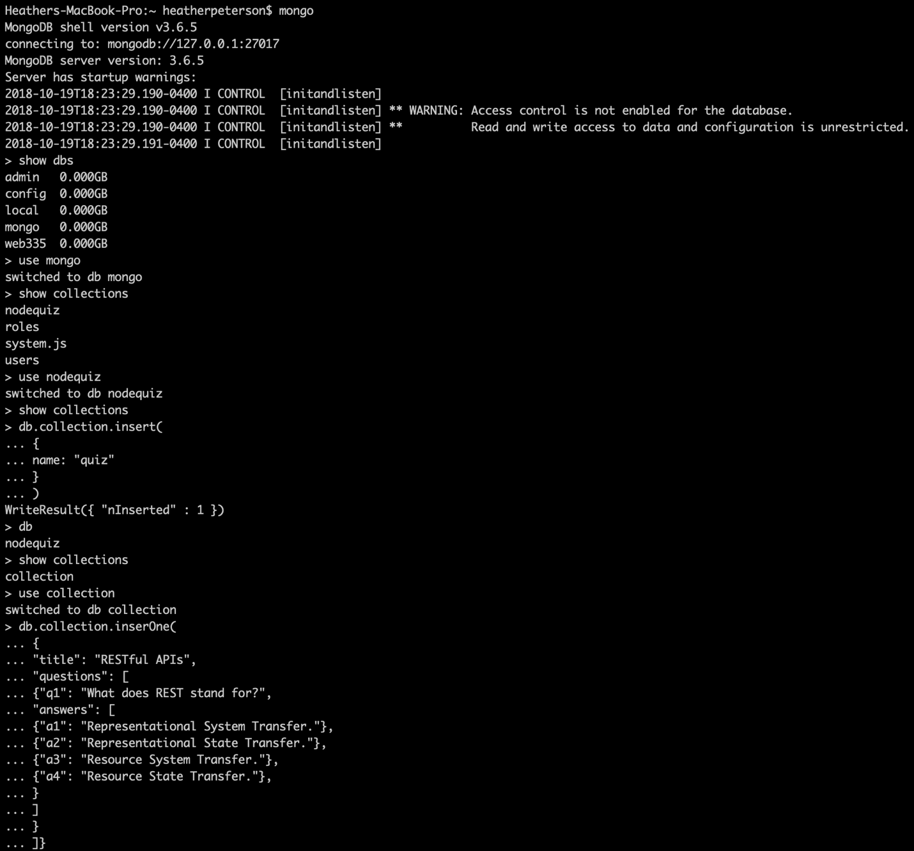

nodeQuiz > server > helpers > config.js

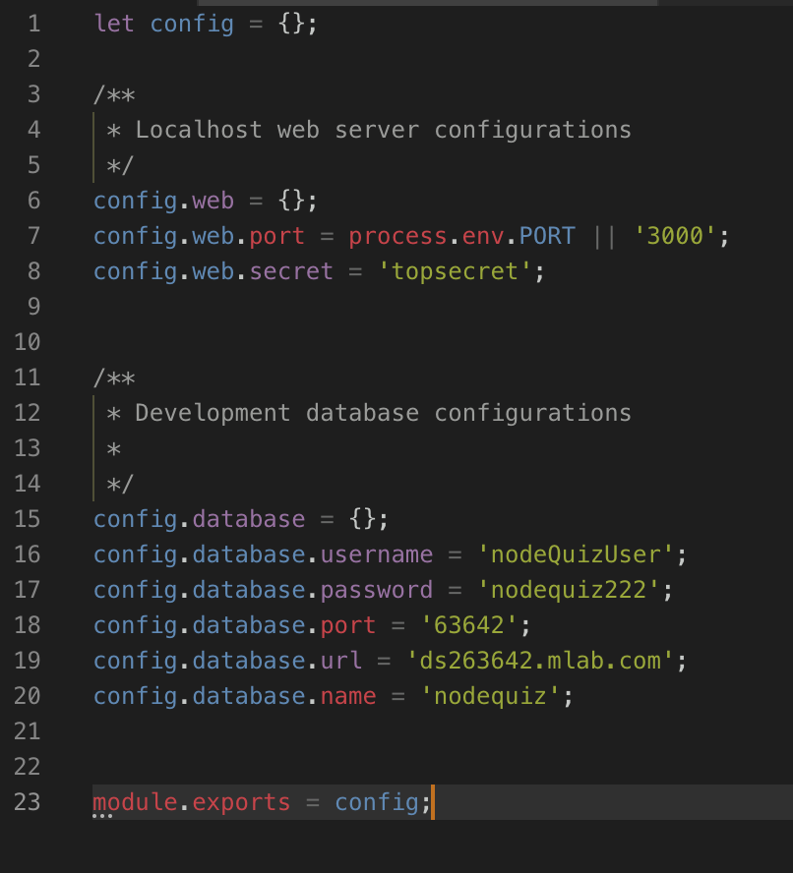

Running MongoDB Compass on **mongo ds263642.mlab.com:63642**

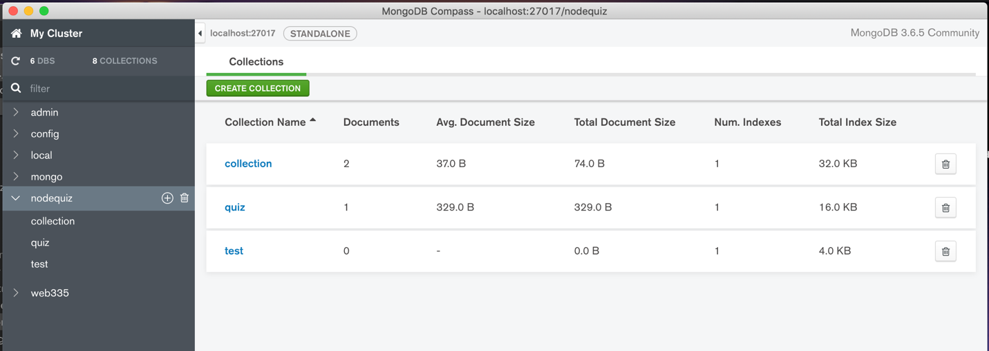

mLab fully managing a cloud database service that hosts the MongoDB database

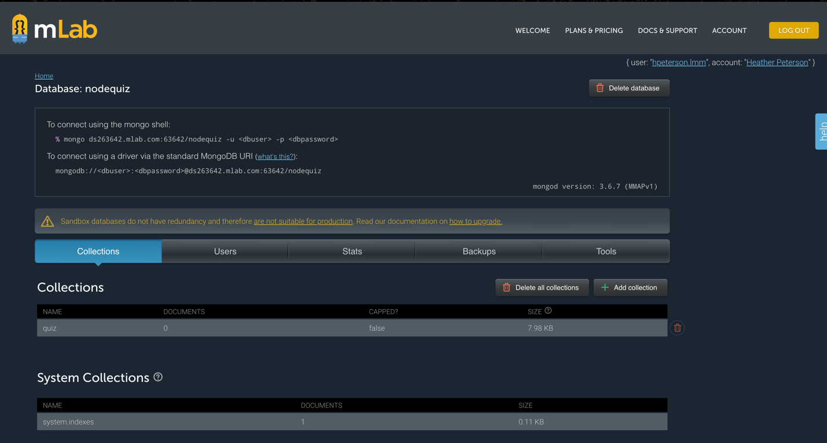

Definition References

Downing, Douglas Ph.D, Covington, Michael, Ph.D, Covington, Melody. (2017). *Dictionary of Computer and Internet Terms – Twelfth Edition.* Barron’s.

Angular.io

Wikipedia.com